Dental Disease
The three most common health problems in dogs are; dental disease, ear infections and obesity. This is pretty shocking when we consider that these things can all be prevented with correct animal husbandry.
Some breeds are definitely more prone to tooth decay than others and the Estrela generally has quite healthy teeth but that doesn’t mean we should be complacent. Here are our top tips for avoiding these problems.
Vigilance – gradually get your puppy or dog used to having its teeth looked at. Take your time as you don’t want to create an aversion by mistake! Keep an eye out for plaque build up and / or red gums or broken teeth. Make sure to look at the back teeth as well as the front ones and on both sides as there can be an issue with individual teeth.
Mouth conformation - Estrelas can have teeth that don’t fit together correctly. This means they then don’t chew and clean their teeth properly so make sure you know what is going on in your dog’s mouth. Being over shot or having a parrot mouth, is when the dog’s top jaw is too long. This probably causes the biggest problems as the lower canines can end up digging into the roof of the mouth, making it very sore! You will need to talk to the vet if this is happening.
Chews – there is a whole range of things you can buy your dog to chew. It may be trial and error finding something they like, but it is important that they always have something to chew as this is the primary way a dog keeps its teeth clean. Some estrela owners have told us that their dogs’ favourite chews include: paddy whack, nylabones, beef bark, antlers, hooves, horns, coffee wood, yak chews, raw hide and somewhat more messily, chicken backs and turkey necks. Now some chews are not eaten and have no calorific content but others are eaten and can be quite high in sugar or fat depending on what they are made of so do take this into consideration and make sure to adjust your dog’s actual food accordingly.
Food – if you feed soft minces or soaked kibble then your dog will almost certainly need something else to keep its teeth clean although even dry kibble and BARF fed dogs can need some extra intervention sometimes too.
Brushing teeth – it certainly doesn’t hurt to get your dog used to having its teeth brushed, that way if you do notice that they are needing some extra intervention you can start straight away.
Ultra sonic tooth brushes – many groomers have these nowadays and offer this as a service to help remove plaque. You can buy one yourself but do get a pet one as they are much quieter than the human ones and be sure to follow the instructions.
Scale and polish – a last resort for most dog owners. Your vet can perform this under a GA. Hopefully if you take good care of your dogs teeth it won’t be necessary but it can end up necessary. Do see your vet as soon as you are concerned about your dog’s teeth as a scale and polish is much cheaper and better for the dog than having to have teeth removed if the situation is left untreated.
Signs of dental disease – remember Estrelas are very good at hiding pain so changes in behaviour like grumpiness and not wanting to be handled or go for walks can also be an indirect sign. Main symptoms are; tartar, bad breath, pawing at the face, drooling, dropping food, not wanting to eat or eat only soft food, red and inflamed gums, swollen face, missing, wobbly or broken teeth and weight loss.
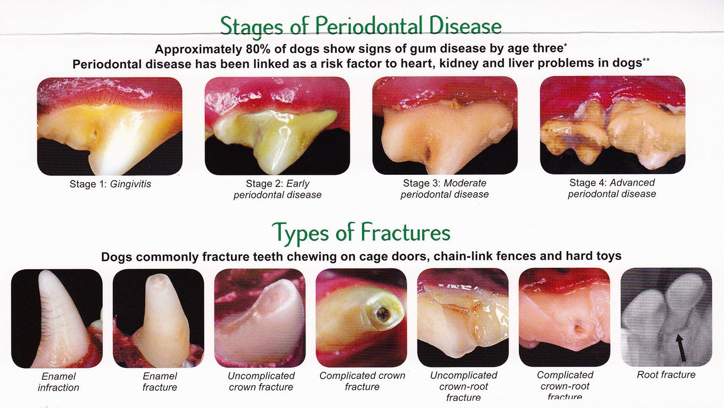Image taken from pinterest, original credit unknown.

